HOW TO SETUP DOCTOR PAGES
- Go to http://doc.activator.com
- Click on Login
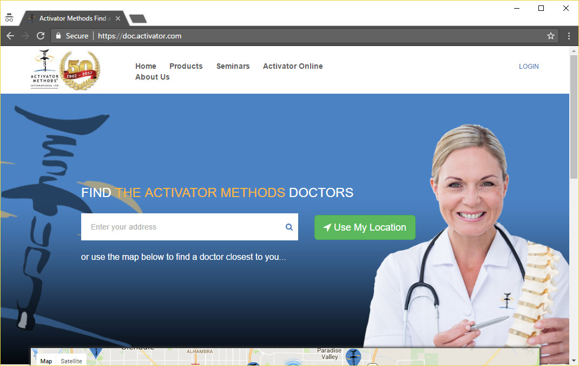
- Enter the provided Username and Password in the appropriate boxes and click Log In To Your Account
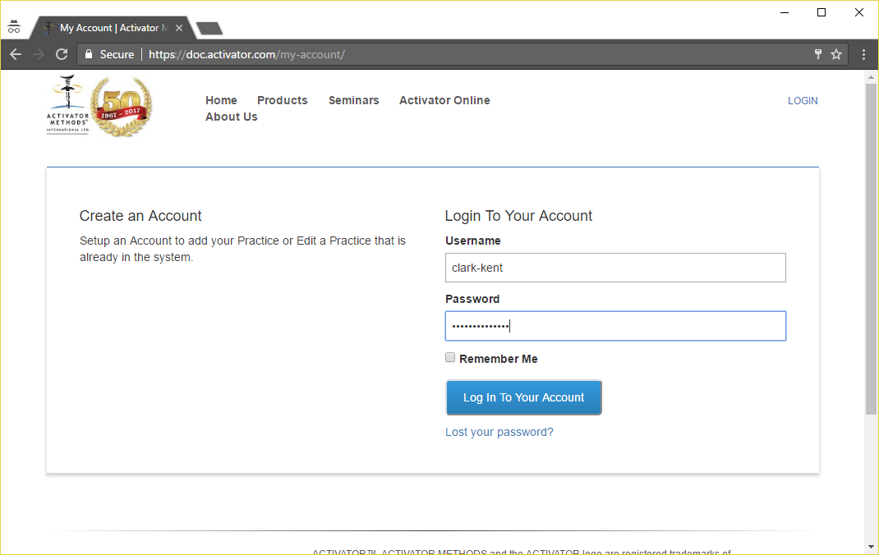
DASHBOARD SECTION
- Click on the Edit button to change information in your Activator web page
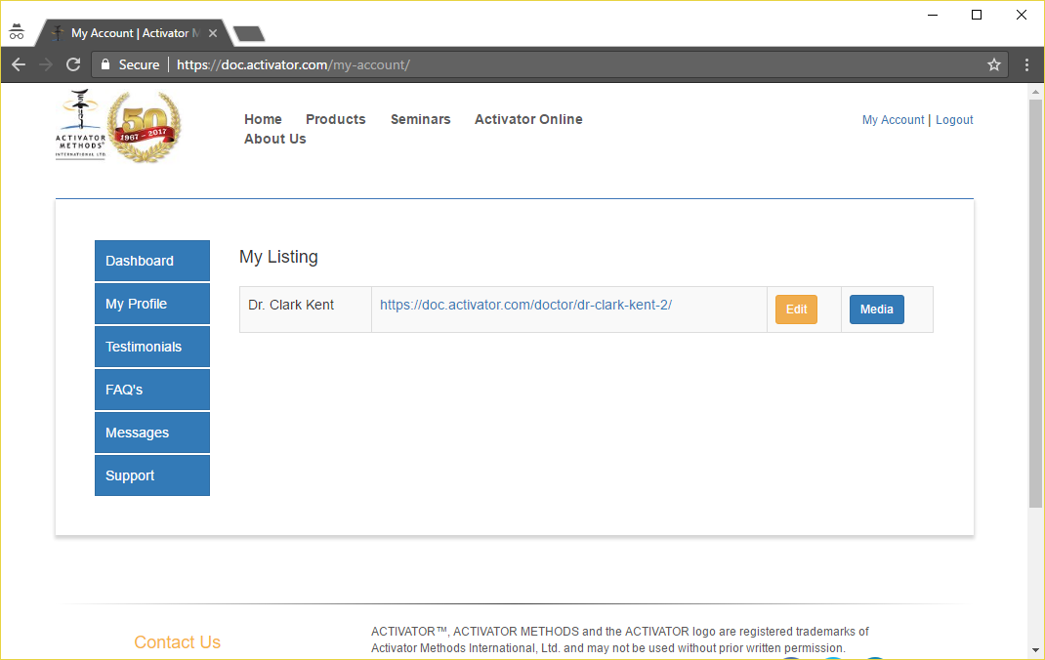
- The fields that are able to be updated include the following
  - Title – This should be the Doctor’s name or the name of the Clinic
  - Description – This should a 1000 word or less biography of the Doctor, clinic or a combination of the 2
  - Video – This should be either a video of the Doctor, their clinic or the Activator introduction video found @ https://www.youtube.com/watch?v=Z7IhwsVXJfo
  - Contact information – This includes the following fields that MUST be filled in
    - Phone Number
    - Address Line
    - City
    - State
    - Zip
    - Country
    - Neither Latitude, Longitude nor Map Zoom Level are requirements, but they can be entered if desired
  - Office Hours – These have now been updated to allow for a lunch period. If the office is not going to be open all day, just click the Closed check box.
  - Email Address – This can be a front office staff email address, or directly to the Doctor
  - Website URL – If the Doctor/Clinic has an existing page they can link to it through this box
  - Social Media – None of these are required, and they will not show on your Activator page unless they are properly filled in
  - Features – Please select all of the features that the Doctor/Clinic offers
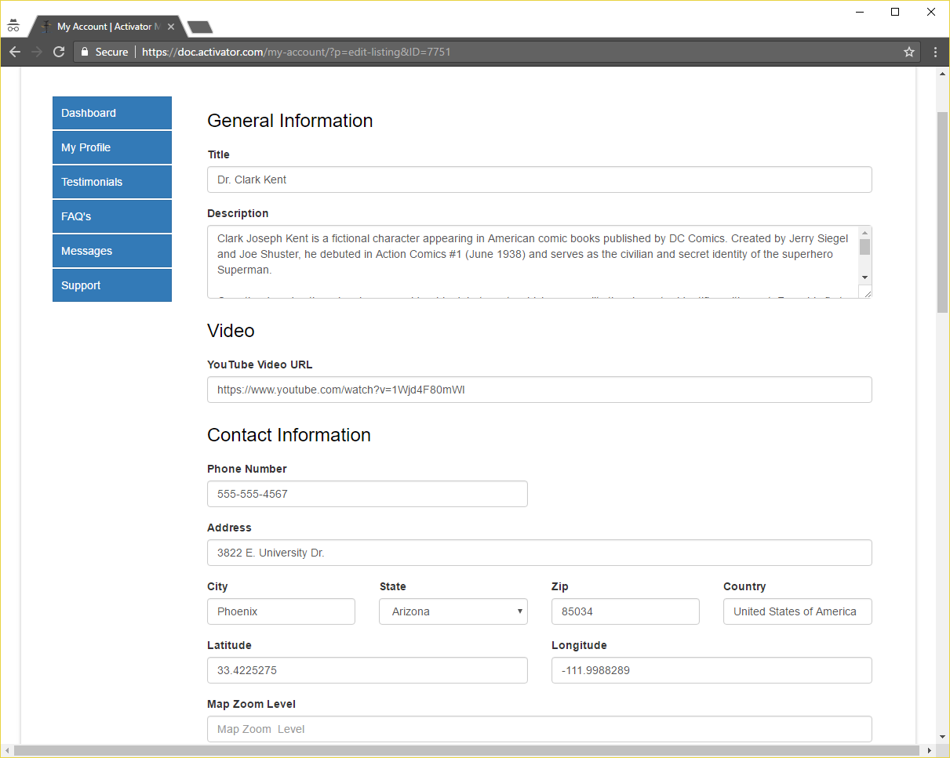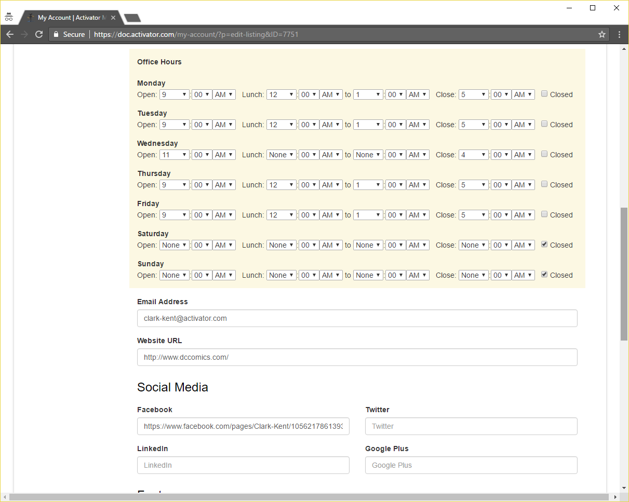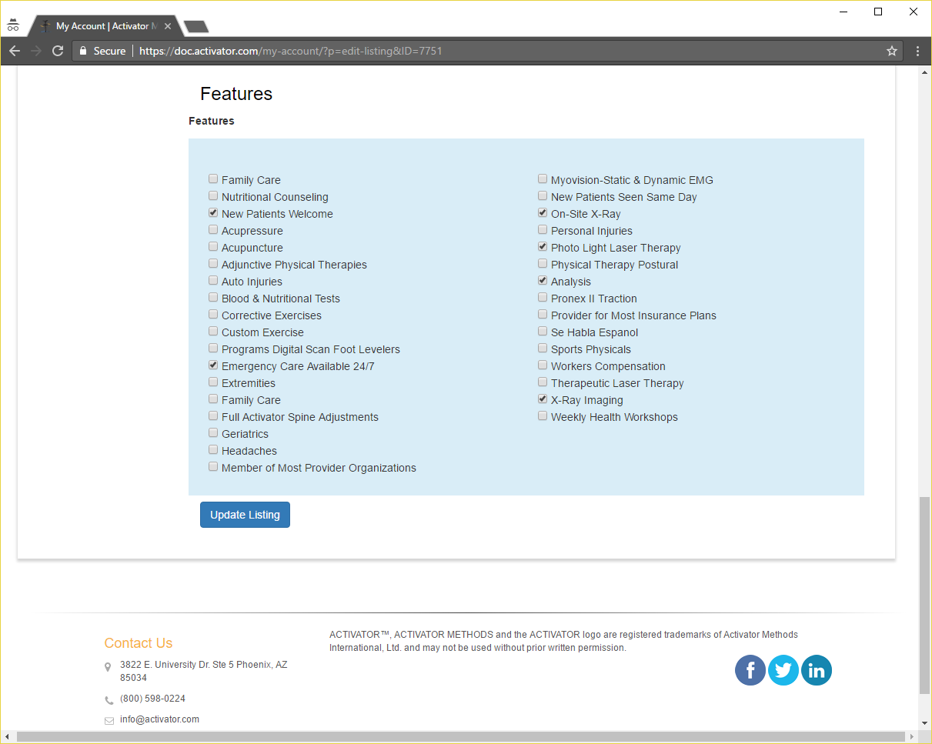
- To add photos click on the Dashboard button to get back to go back to the Listing view and Click on the Media button
- Each image will need to be individually selected and then uploaded
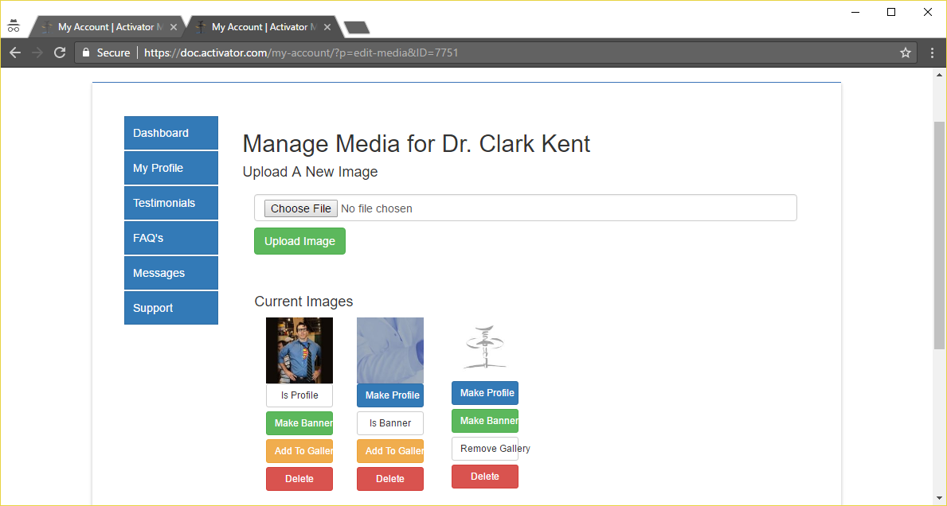
- Once the images are uploaded the Profile, Banner, and Gallery photos need to be selected by clicking on their icons.
MY PROFILE SECTION
- In this screen passwords and Activator Contact information can be updated. None of this information is used in your Activator Webpage. It is just your User Profile for the website’s login directory.
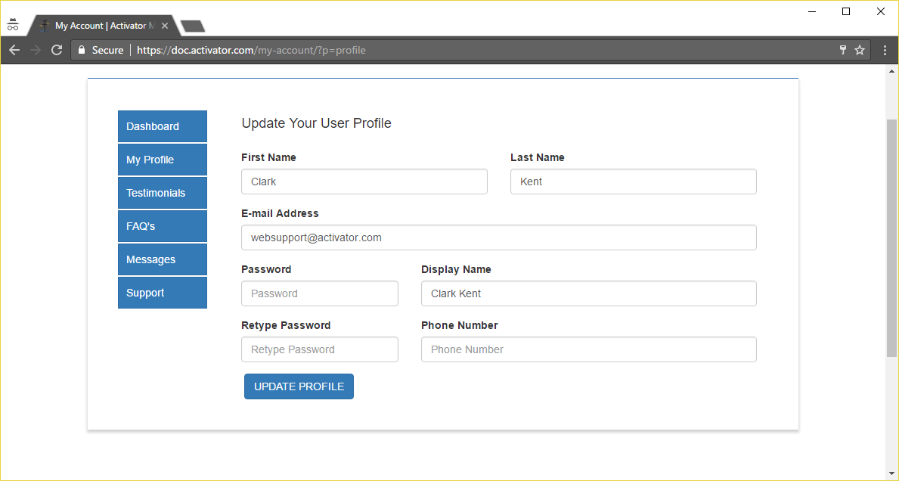
TESTIMONIALS SECTION
- In the testimonials section, patient testimonials can be added by the Doctor/Clinic Staff. Patients do not have the ability to submit their own Testimonials. They must be input by the Doctor/Clinic Staff/Activator Staff.
- To get start click + Add Testimonial
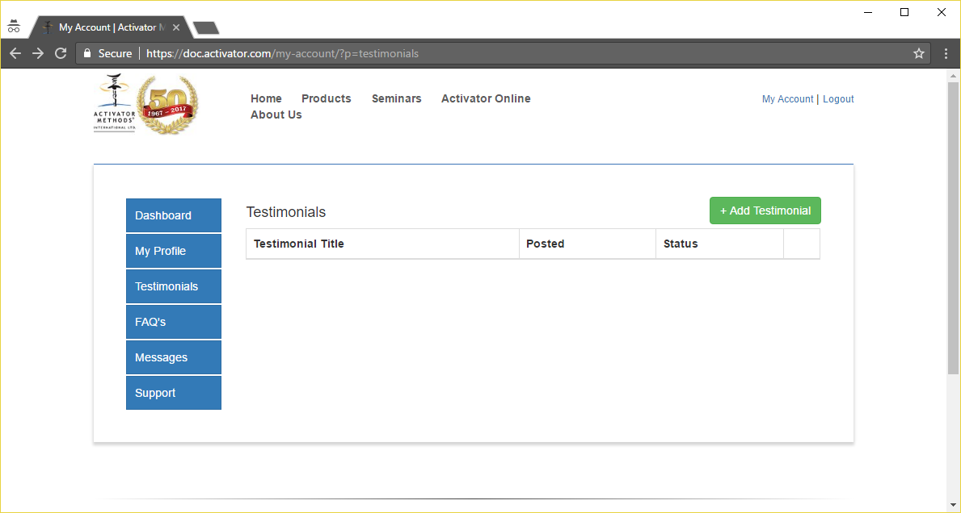
- Input a catchy Testimonial Title in the Subject Section, then complete the entire Testimonial and click Add Testimonial
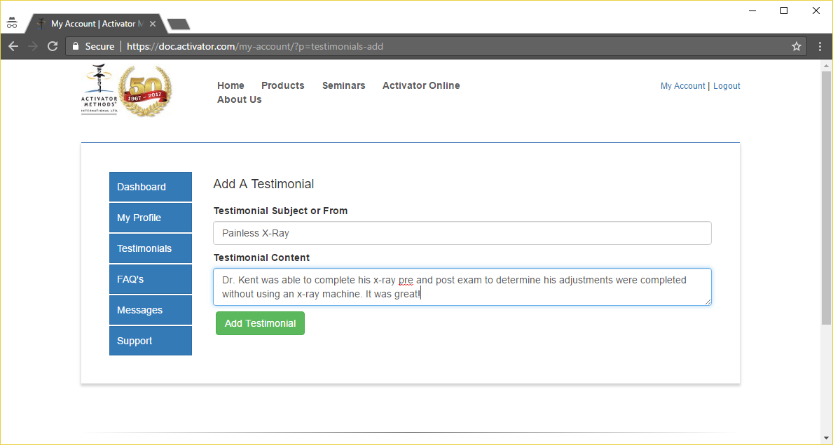
- Once completed the Testimonial will be submitted to Activator Staff for final approval prior to it posting to the Doctor/Clinic’s page.
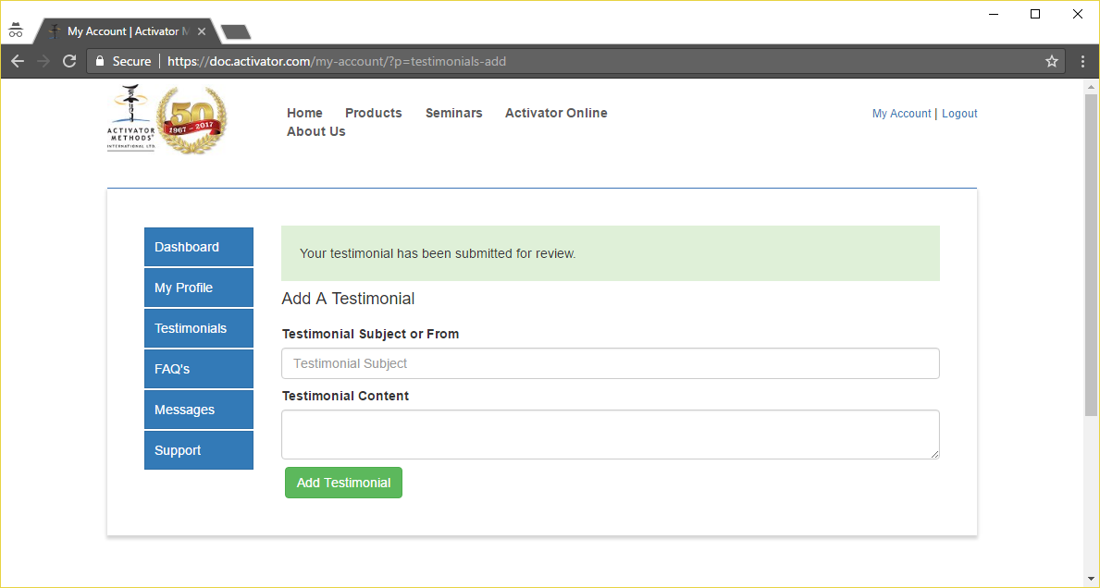

FAQ SECTION
- In the FAQ section the Doctor/Clinic Staff can input any of their Frequently Asked Questions and Answers by click on the + Add FAQ button
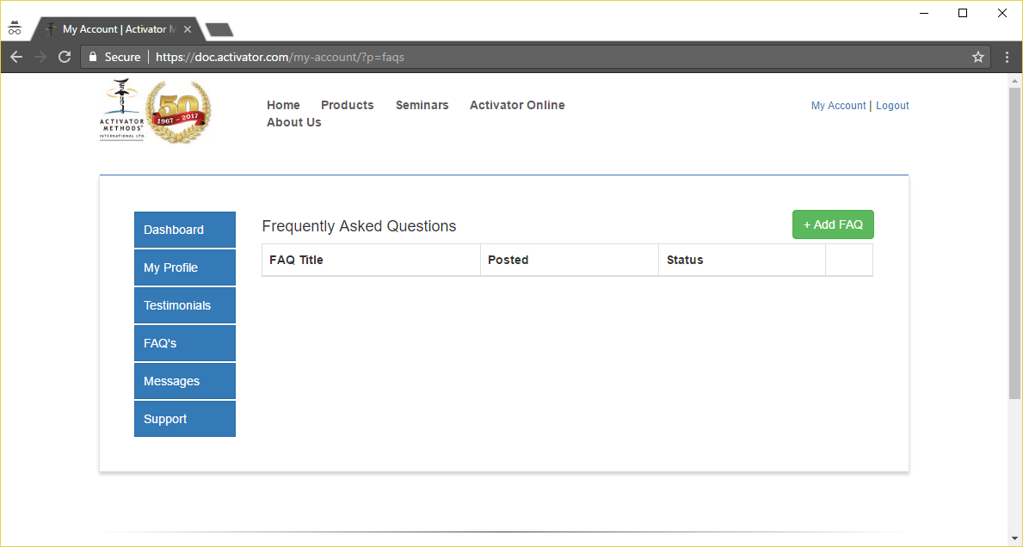
- Enter the FAQ into the FAQ Question box and the Answer in the appropriate box and click Add FAQ
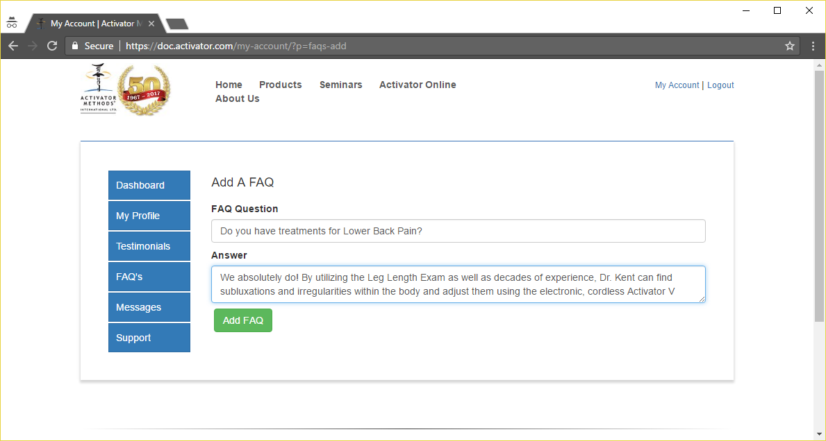
- Once completed the FAQ will be submitted to Activator Staff for final review and posting
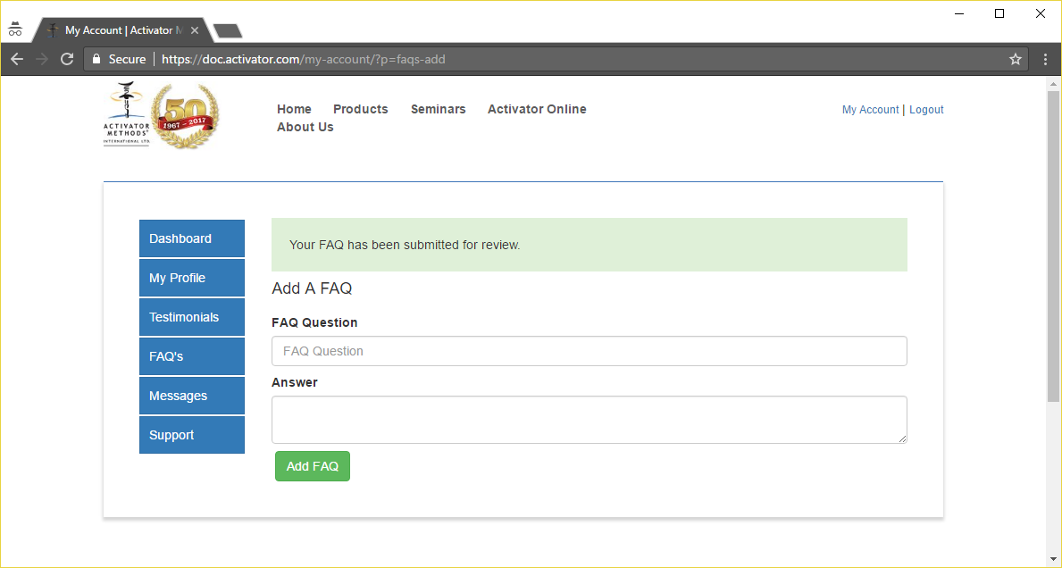
MESSAGES SECTION
- The messages section is where all inquiries made from your Activator page will be stored in full compliance with HIPAA requirements regarding transferring of patient information. This is where you will go to see new messages and answer them. Start by clicking on Messages and then if there are any showing, click on the View button.
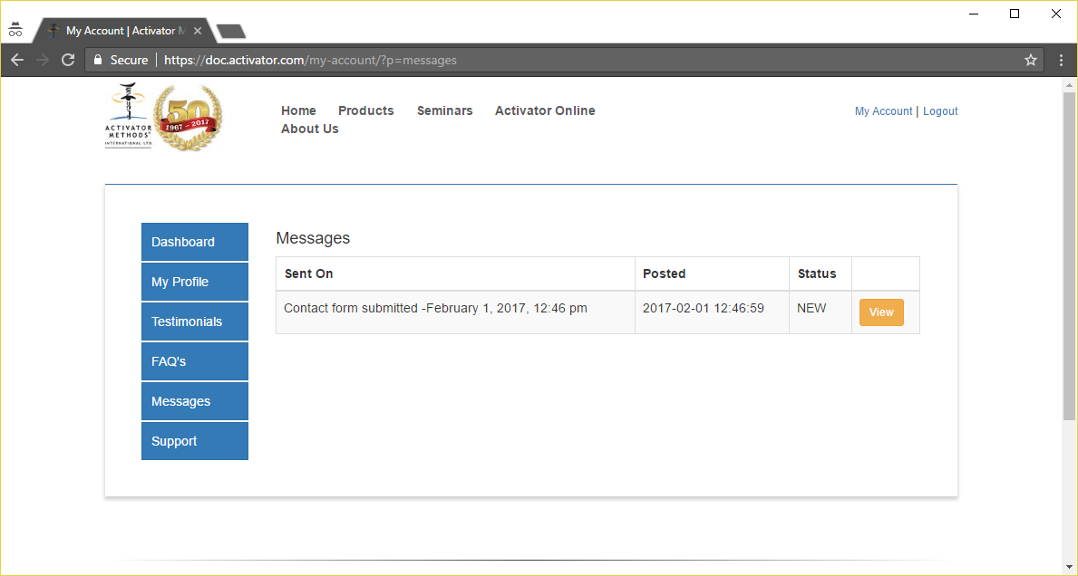
- The message as well as the patients contact information will then be displayed through the secure Activator.com website
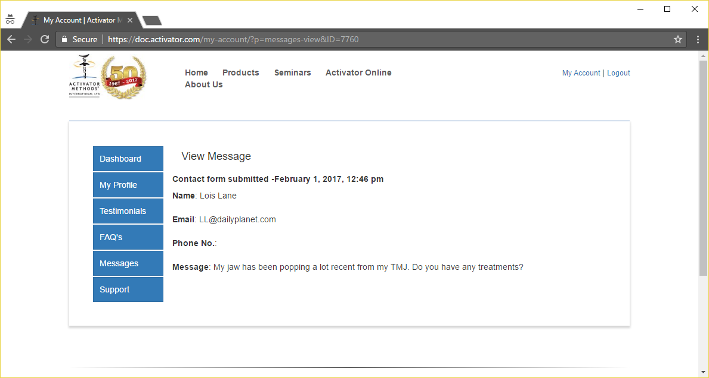
- Once the message has been viewed the status on the Messages section will update from NEW to seen
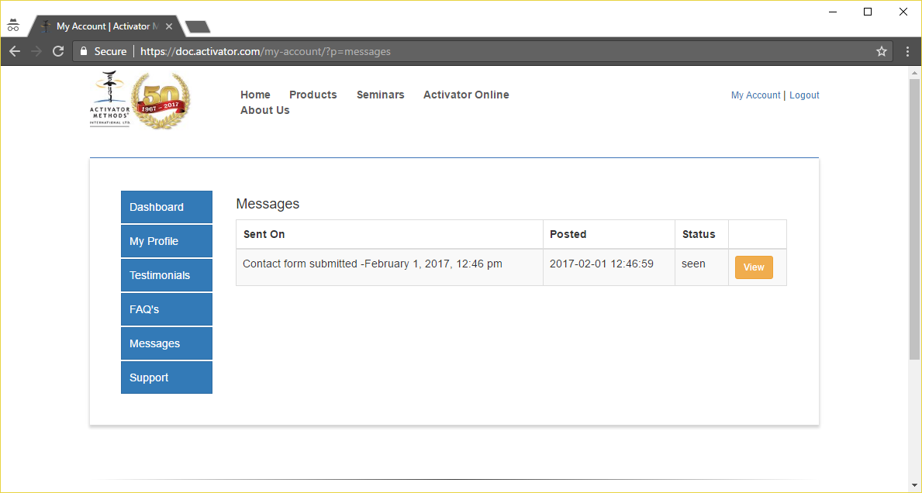
SUPPORT SECTION
- The updated Find a Doc website now includes an option to send a support request directly through the website. Fill in all the required information as well as selecting the reason for contacting support and Click Send Your Request.
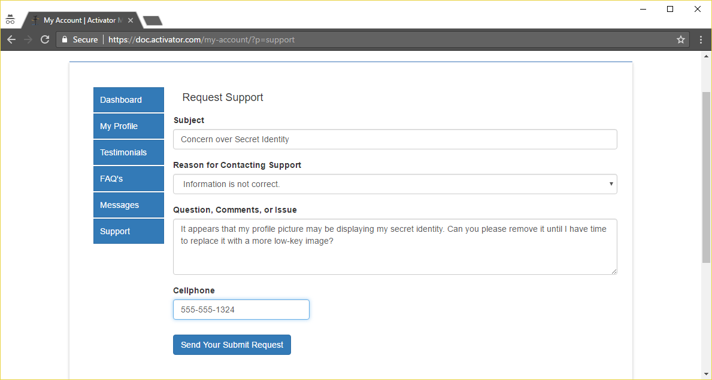
COMPLETED PAGE REPRESENTATION
